**Media Assets Center: Burnt in Time Code (BITC)**

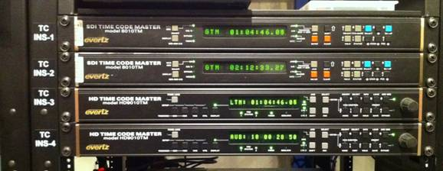

We currently have 4 TC Gens: (**TC_GEN_1**, **TC_GEN_2**, **TC_GEN_3**, and **TC_GEN_4**). TC_GEN 1 and 2 are SD and TC GEN 3 and 4 are HD. You can access them either through XY Mode or from the MultiDest main menu on PG 27 of any router panel (below).

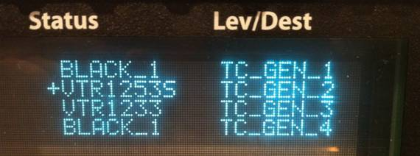

The TC GENs pass through video, so all you will need to do is route your source deck to your selected TC GEN and then route the TC GEN to your destination deck when going SD to SD (TC_GEN 1/2) or HD to HD (TC_GEN 3/4).

If you need to go HD to SD, you will need to first route your source deck to one of the **Up Down Cross Converters (UDXC_1 – UDXC_11)** and then route that converter to the TC GEN 1 or 2 before routing the TC GEN to the destination deck.

**Troubleshooting**

If you don’t see the TC on your output, make sure the generator is on (ON/OFF button).

If the TC appears in the wrong place, use the arrow buttons to position it.

If the wrong TC is displayed, double check your routing.

If you’re not seeing the T1 time code, hit the VCG-Mode (#6) button to cycle through the different time codes. Each of these is subject to the same ON/OFF and moved-by-the-arrows functionality.